## SOFTWARE QUALITY ASSURANCE MANAGEMENT

## NAME:S.Logitha

## REG NO:192121138

**AIRLINE RESERVATION SYSTEM UML DIAGRAM**

**1.USE CASE DIAGRAM**

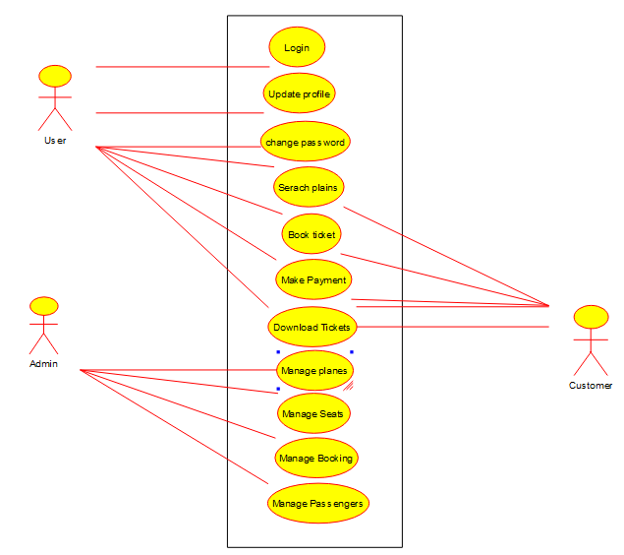

**2.SEQUENCE DIAGRAM**

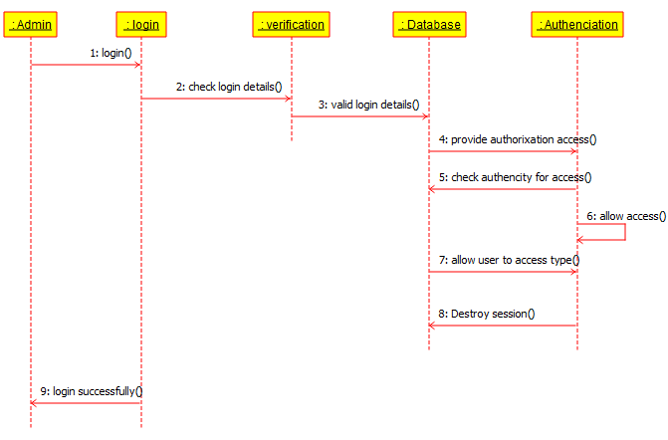

**3.CLASS DIAGRAM**

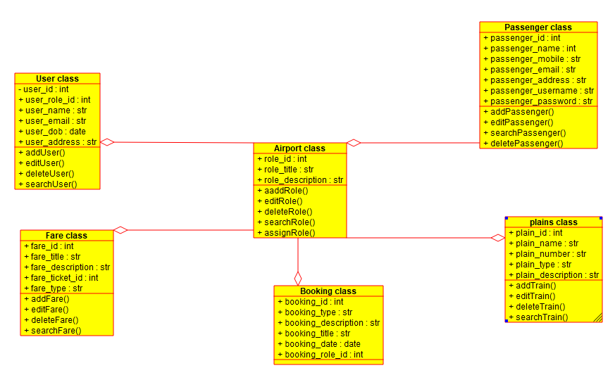

**4.STATE DIAGRAM**

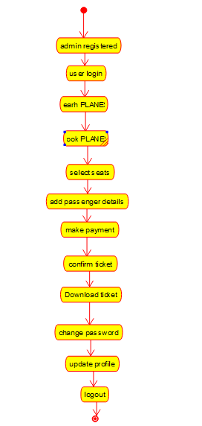

**5.ACTIVITY DIAGRAM**

